**INTRODUCTION**

Prosthetics is the evaluation, fabrication, and custom fitting of artificial limbs, known as "prostheses." Prostheses enhance the function and lifestyle of persons with limb loss. The prosthesis must be a unique combination of appropriate materials, alignment, design, and construction.

Lower-limb prostheses might address stability in standing and walking, shock absorption, energy storage and return, cosmetic appearance, and even running, jumping, and other athletic activities. Upper-limb prostheses might address reaching and grasping, occupational challenges including hammering, painting, or weight lifting, and activities of daily living like eating, writing, and dressing.

Prosthetic patients may have been born with limb deficiency or have experienced amputation due to trauma, cancer, infection, or abnormalities in blood vessels or nerves.

**OBJECTIVE**

The objective of this project is to facilitate the people, in need for help , to get better access to

artificial body parts. The project focuses on making it easier to find artificial legs, hands, fingers,

teeth and ears. This is a portal which gives easy access to all prosthetics in one place.

TABLES INVOLVED

* Hands
* Legs
* Ears
* Teeth
* Fingers
* Manufacturers

A close up of text on a white background

Description generated with high confidenceER DIAGRAM

A picture containing text, map

Description generated with very high confidenceSchema diagram

SCREEN SHOTS

1)

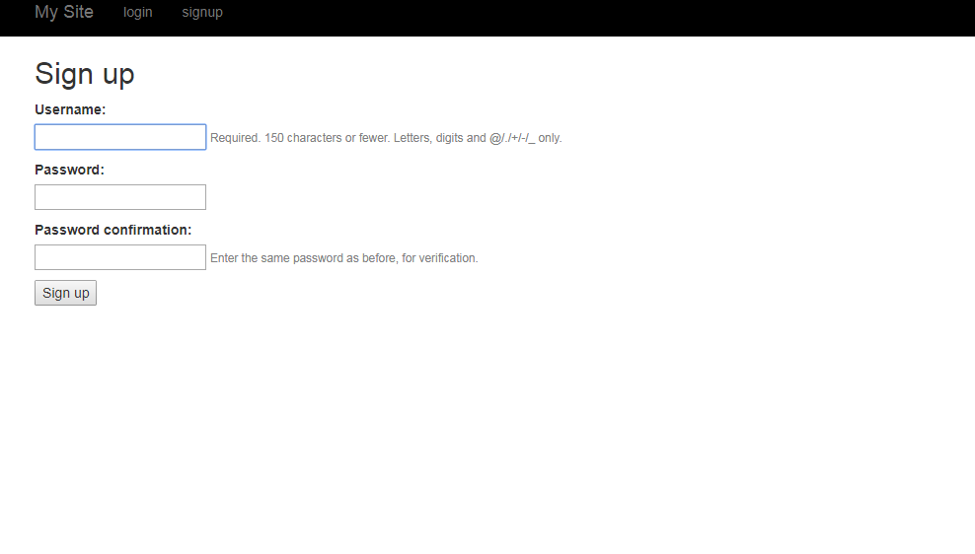

2)

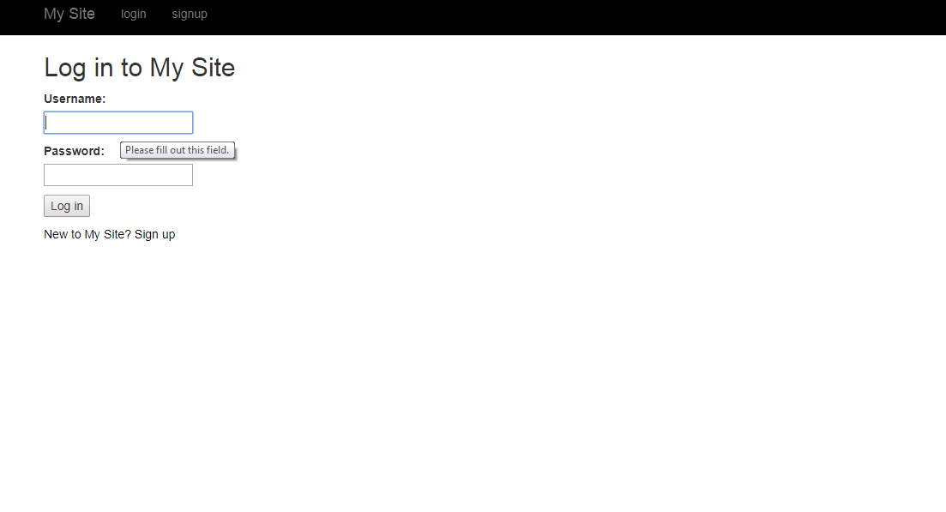

3)

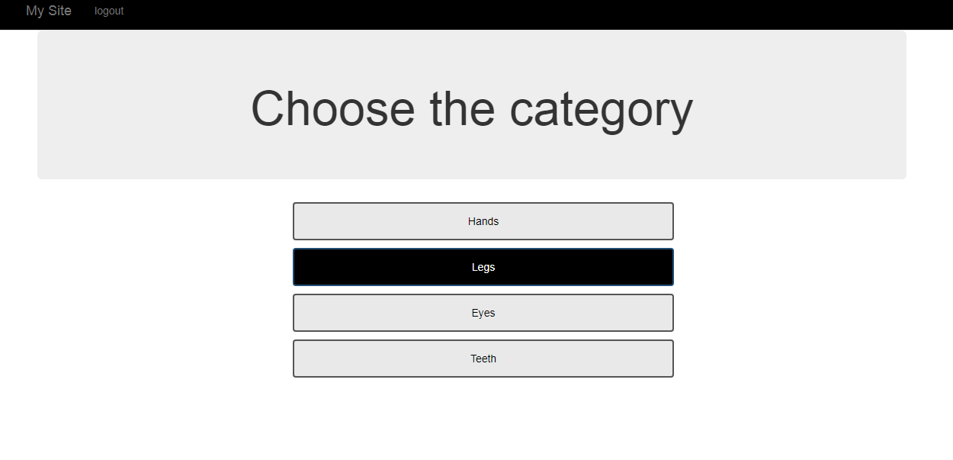

4)

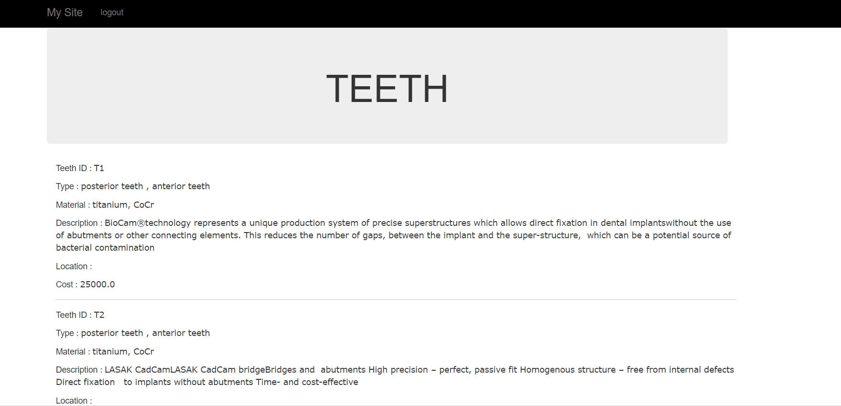

5)

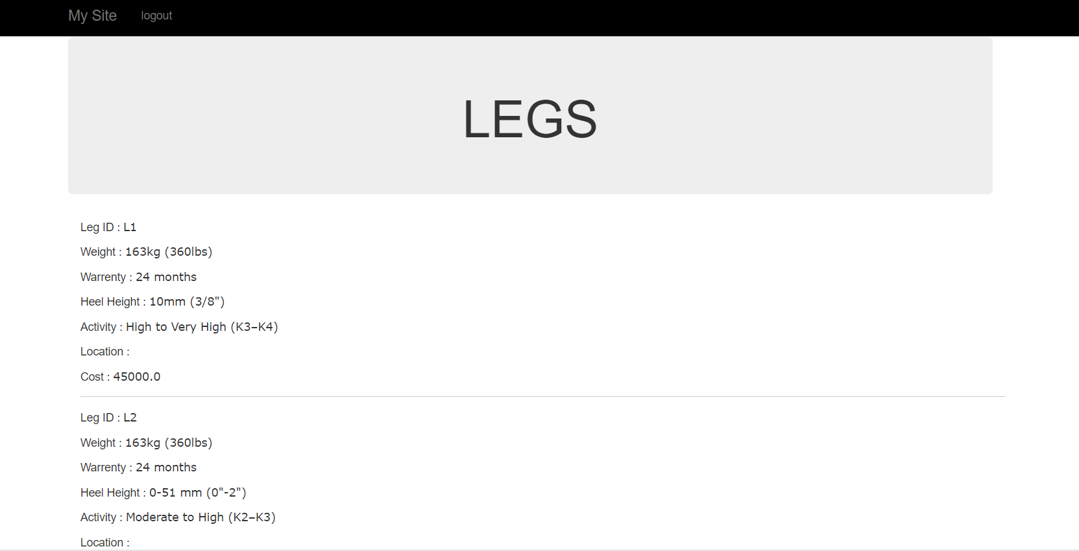

6)

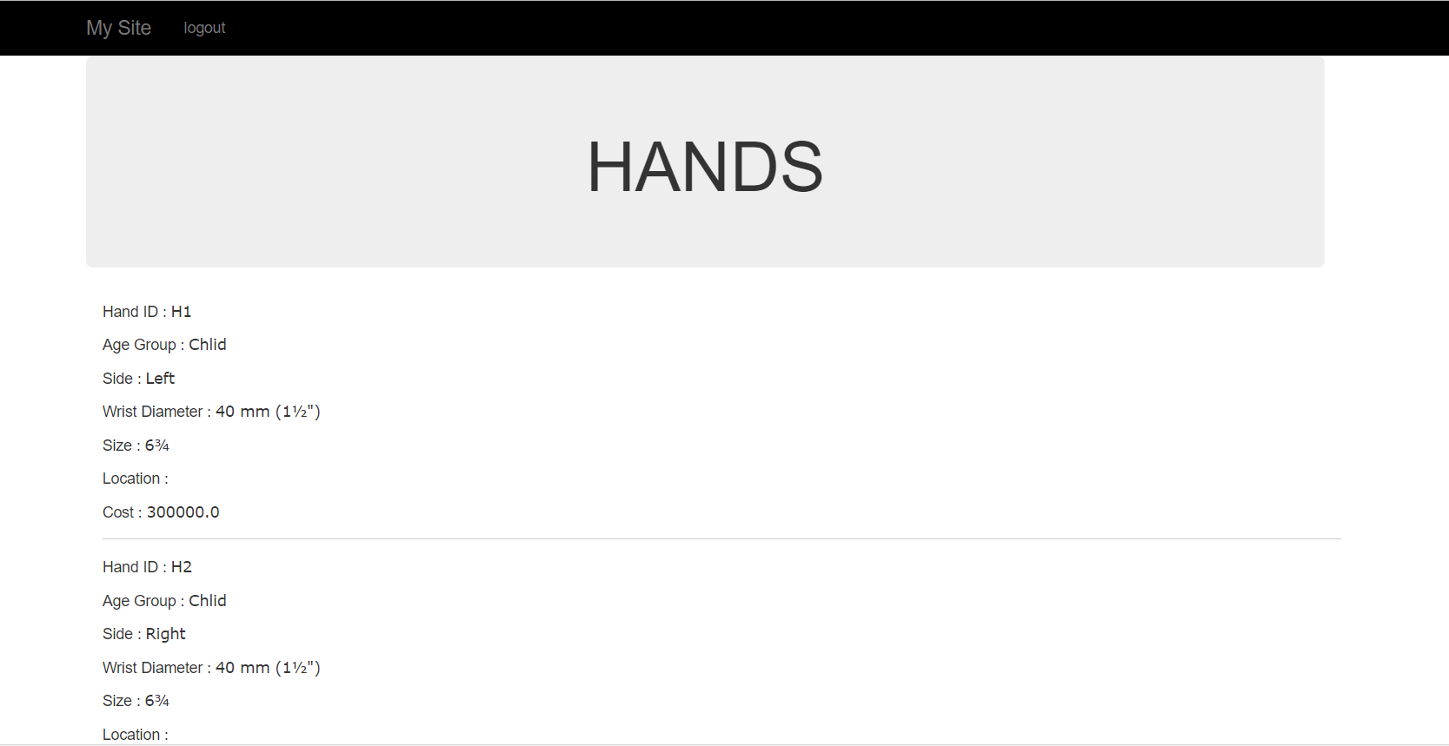

7)

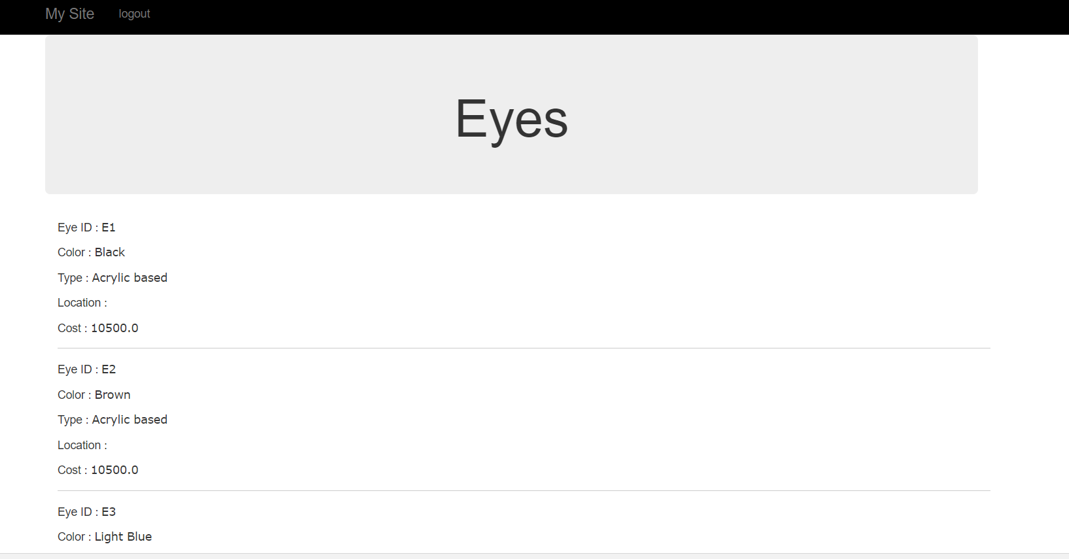

8)

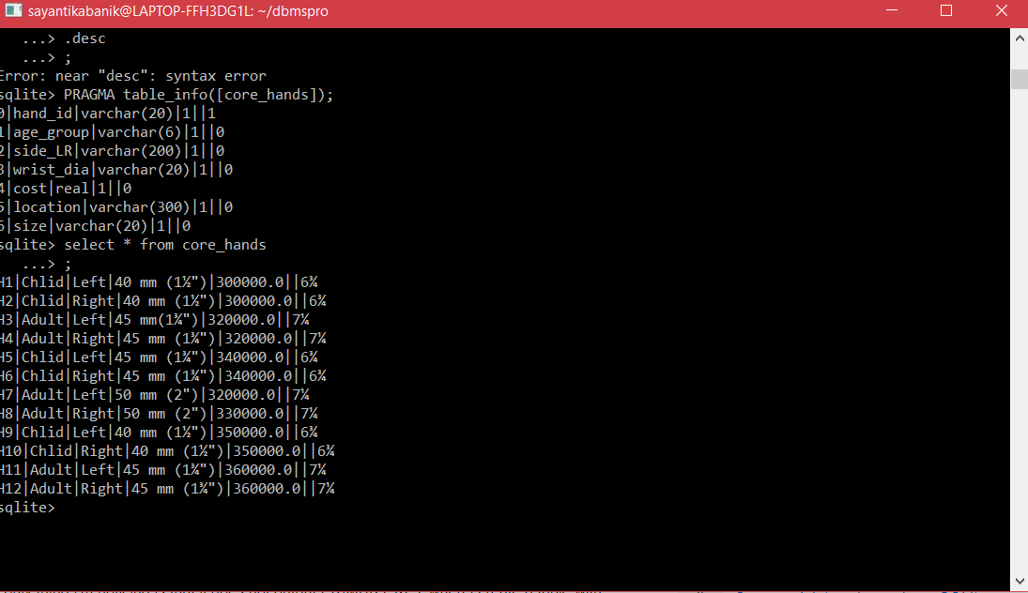

9)

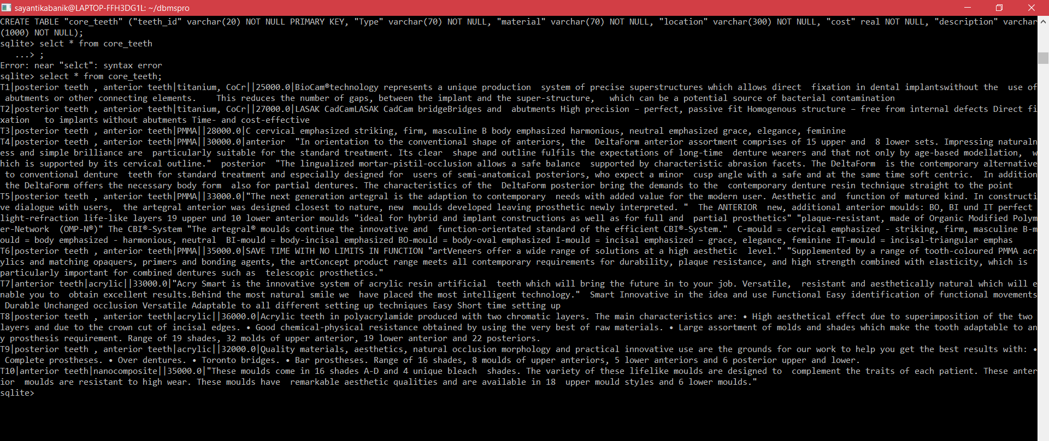

10)

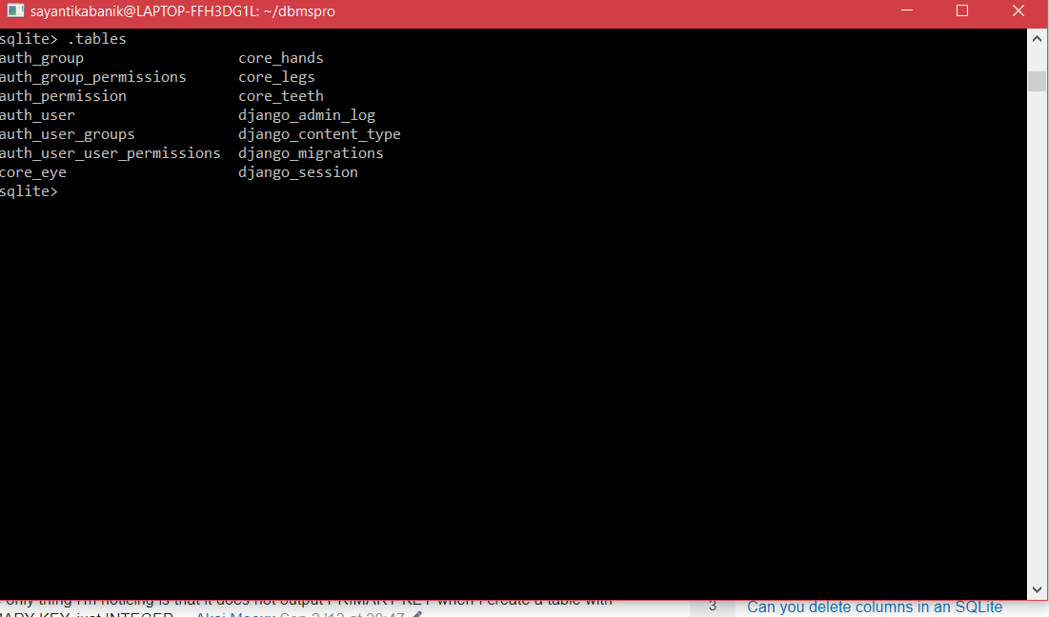

11)

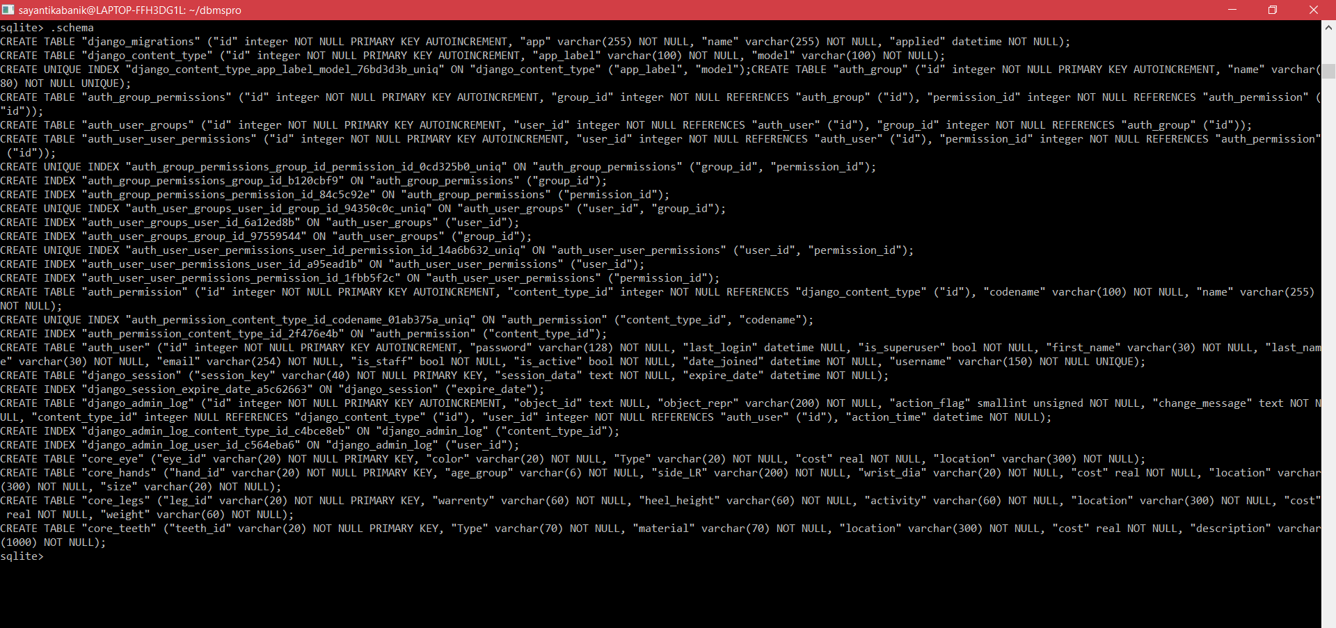

Description of pages

1)Sign up page - Facilitates users to create an account in the website.

2)Login page - Facilitates signed up users to use the website

3)Categories page - Lists the types of prosthetics on the website

4)Teeth page - Lists the types of teeth available

5)Legs page - Lists the types of legs available

6)Hands page - Lists the types of hands available

7)Eye page - Lists the types of eye available

8)

9)

10)

11)

IPOA map of a sign

Description generated with high confidence diagram